**AIDI-2004: Artificial Intelligence in Enterprise Systems**

**Lab #1 – Git, GitHub, GitLab**

**Value:** 10%

**Introduction:**

You have learned about git, github and gitlab. In this lab, you will have hands-on experience by installing and using them in your machine.

**Instructions:**

Step 1: Marks: 10

Install git in your local machine

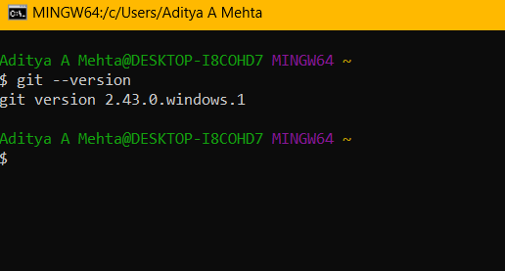

Step 2: Marks: 10

Create user accounts in both github and gitlab

GitHub:

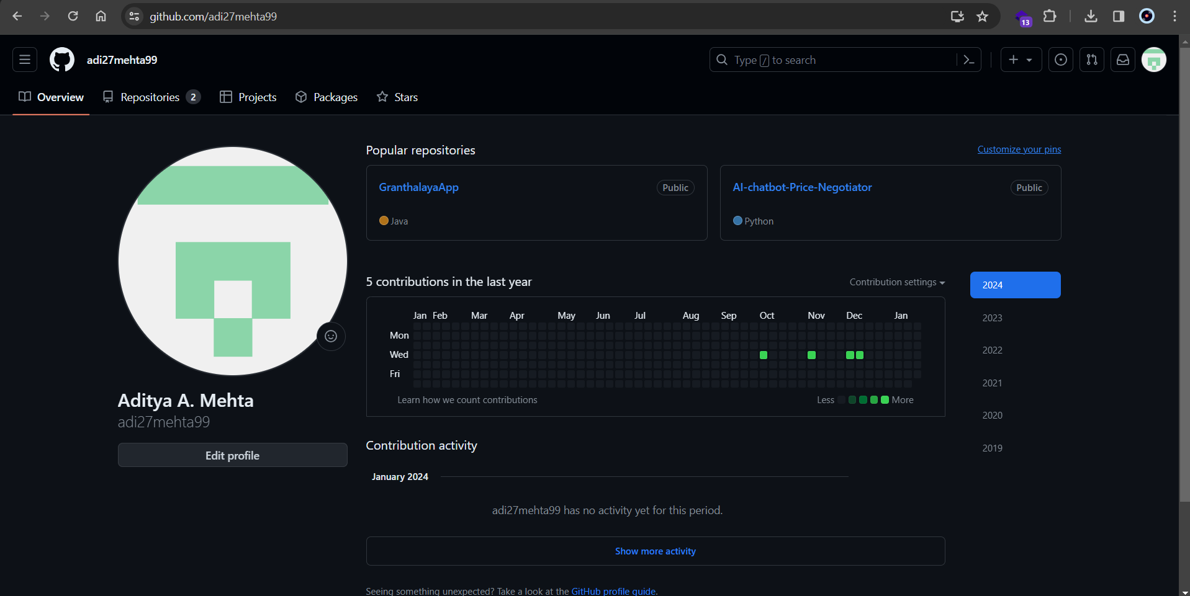

GitLab:

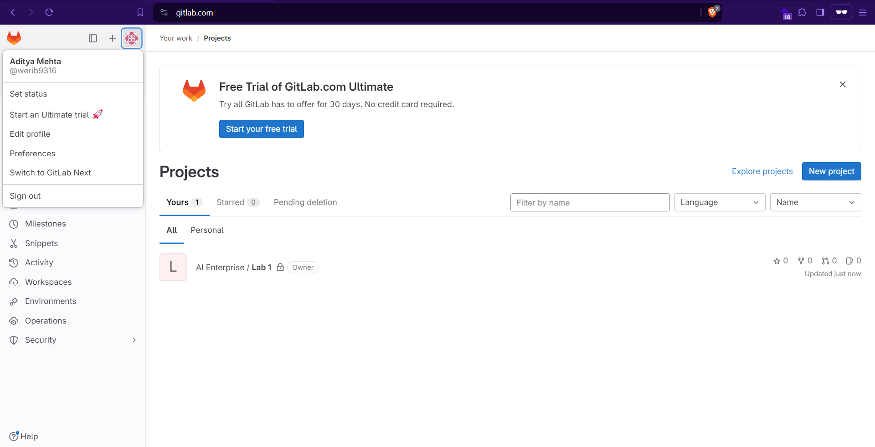

Step 3: Marks: 10

Review github and gitlab. Select your remote host (github or gitlab or any new one) and justify your selection.

Both platforms offer unique features that may be more suited to certain workflows and requirements. However, my remote host would be GitHub as it is widely accepted in the developer community providing better tool for collaboration and sharing projects.

Step 4: Marks: 10

Write a basic program performing key programming activities

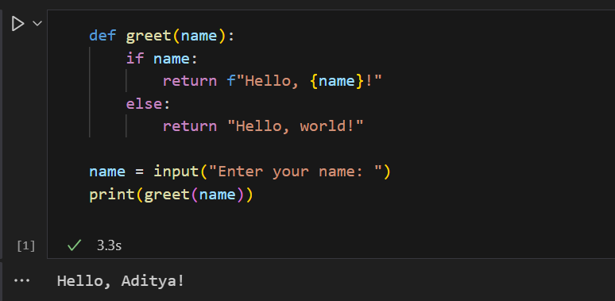

Step 5: Marks: 10

Provide screenshot of your command prompt showing success of your commit in the remote host.

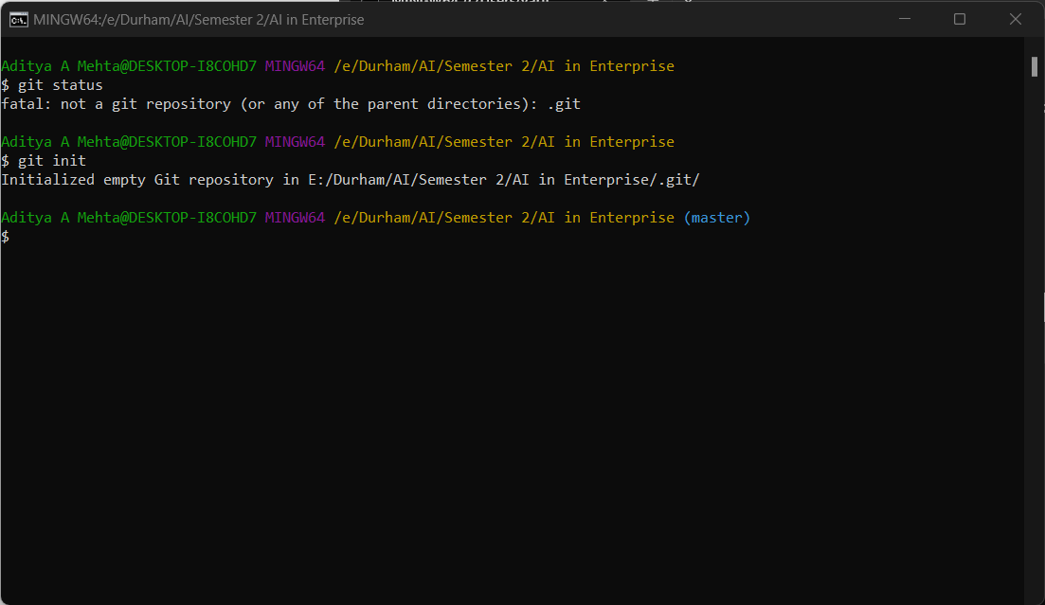

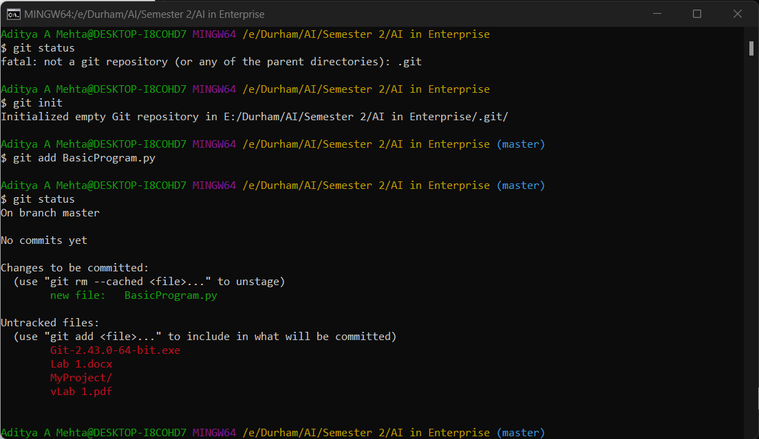

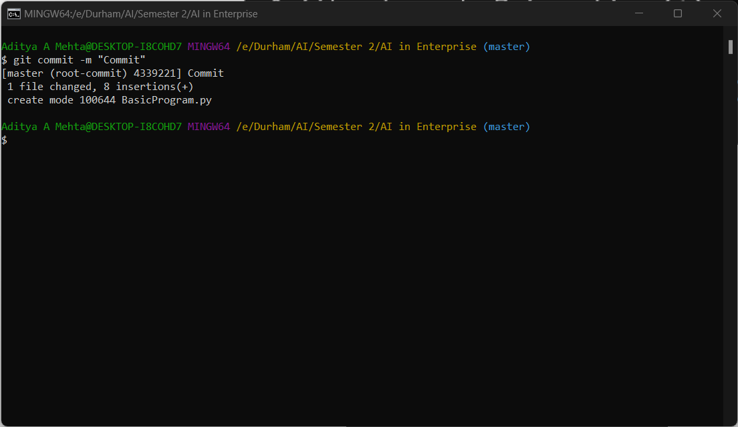

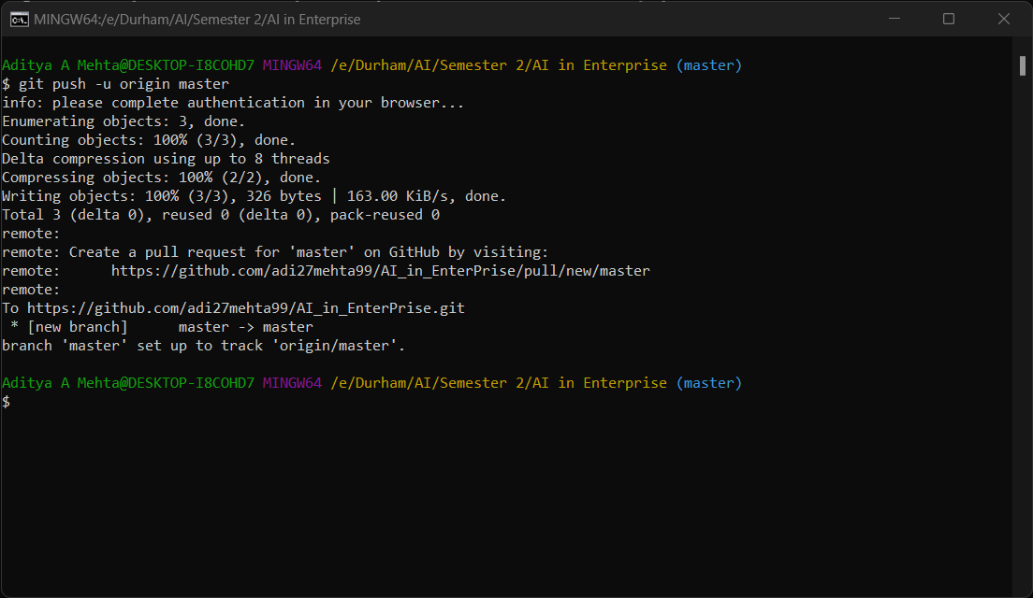

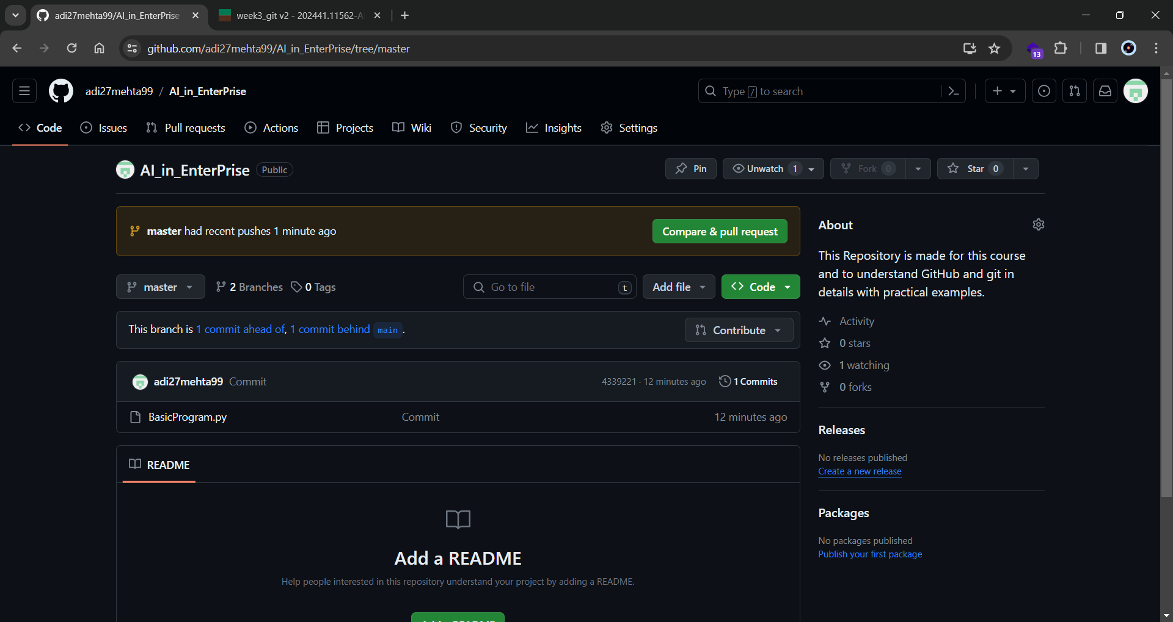

Step 6: Marks: 10

Provide a description of your program in the readme.md file

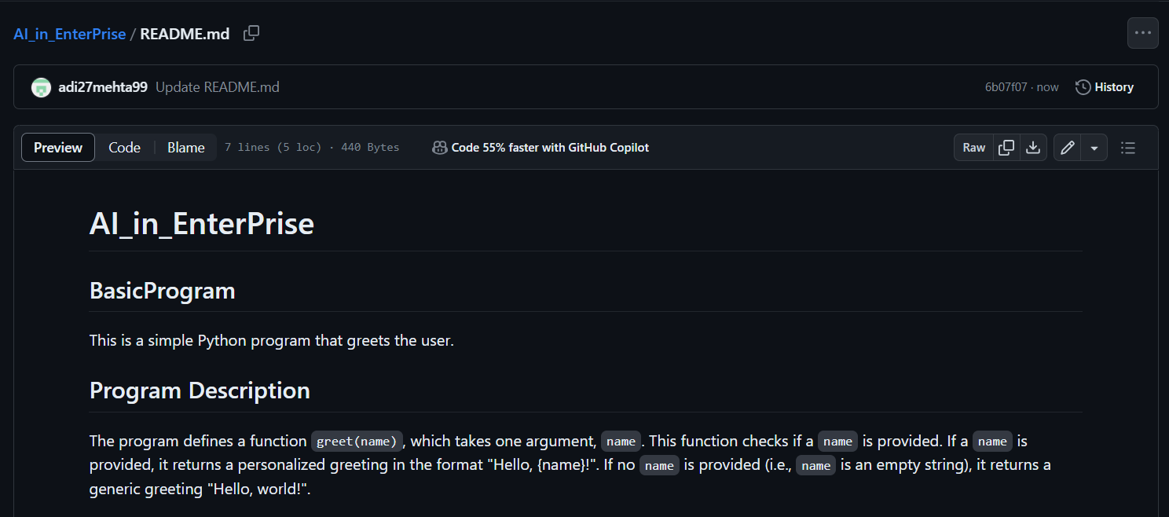

Step 7: Marks: 10

Create a branch in your repo and upload any python script in that branch

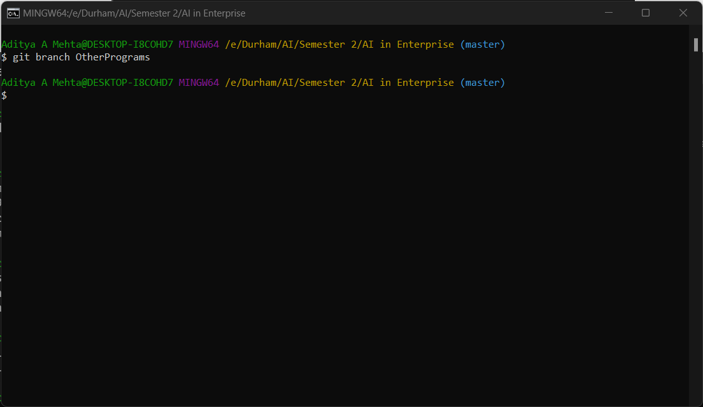

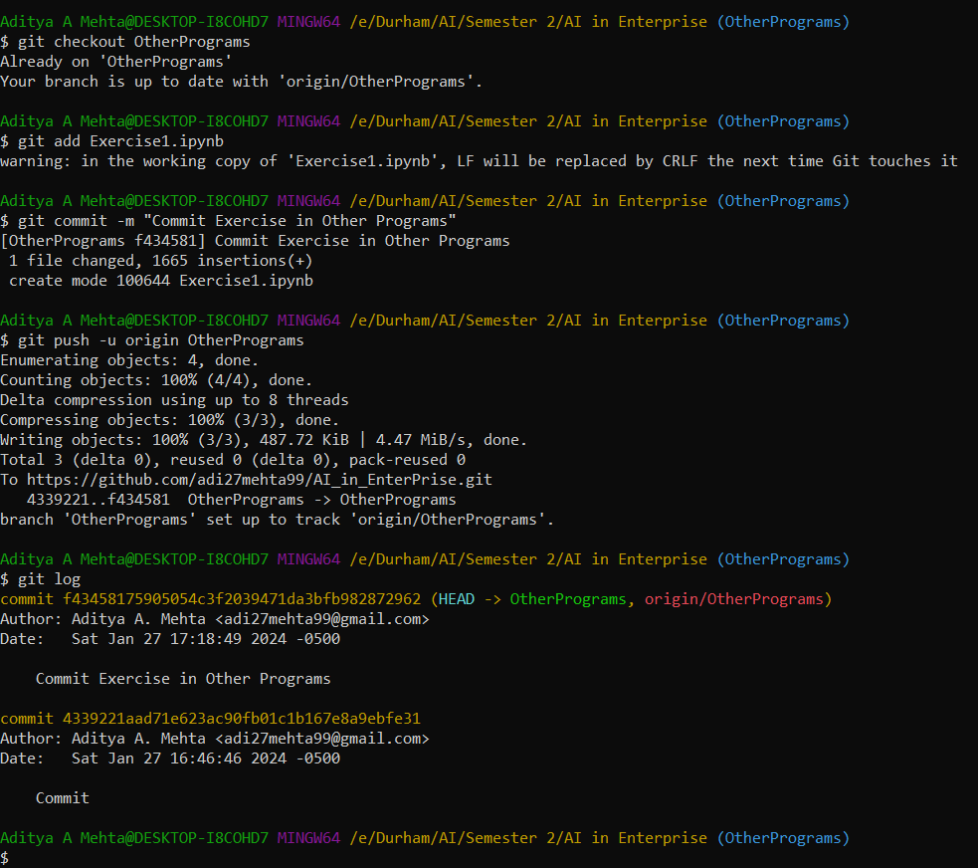

Step 8: Marks: 10

Navigate to your newly created branch and provide screenshot showing status of your repo

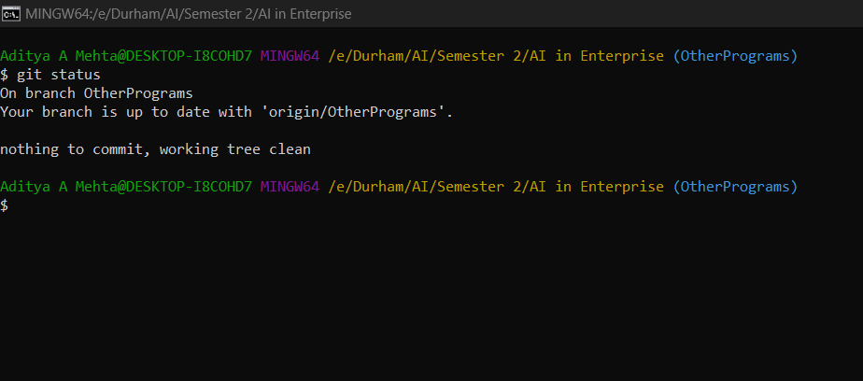

Step 9: Marks: 10

Provide a screenshot showing your log of activities and perform your final commit

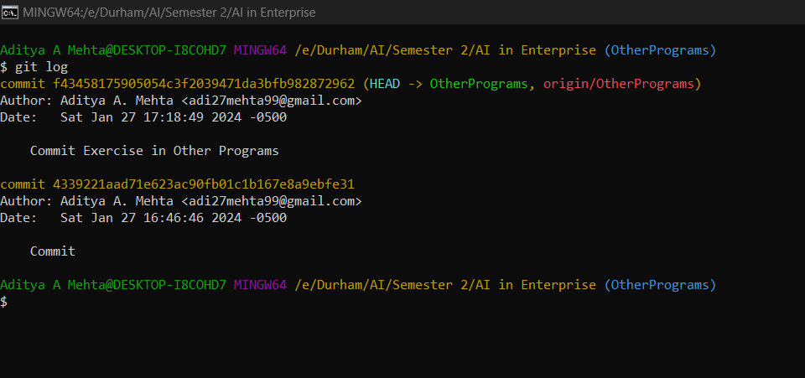

Step 10: Marks: 10

Make your repo public and share the link of your repo for check.

<https://github.com/adi27mehta99/AI_in_EnterPrise>